Bike Sales Analysis - India

- Problem Statement
This project analyzes bike sales data across India to understand how resale value, depreciation, and regional demand influence overall market performance and pricing decisions. It aims to analyze bike sales data to identify key factors affecting resale prices, brand performance, and market trends to support data-driven decision-making for dealers and sellers.

- Dataset Overview
- Rows – 10,000
- Columns – 18
- Key Features –
  - Bike demographics (model, state, fuel type, engine cc, insurance status , registration year)
  - Purchase detail (price , resale price , depreciation, depreciation percentage)
  - Time(manufacturing year , registration year)
  - Missing null values – none.

- EDA using Python
We began with data preparation and cleaning in Python:
- Data Loading : Imported the dataset using pandas.
- Initial Exploration: Used df.info() to check structure and .describe() for summary statistics .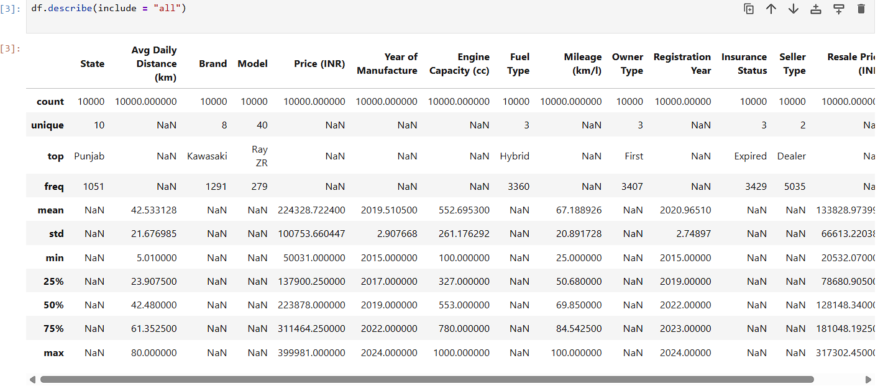
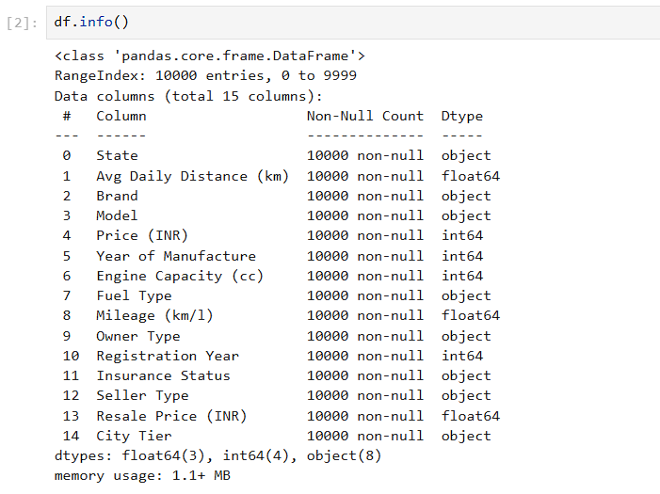

- Missing Data Handling And Duplicated Data: checked for null values and duplicated data.
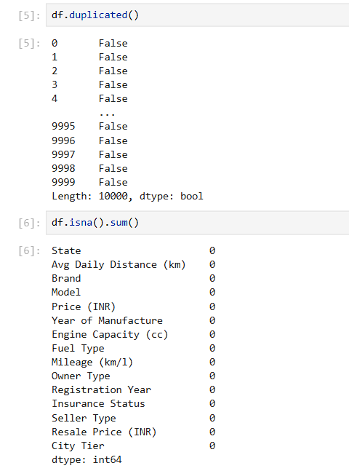
- Column Standardization: Renamed columns to snake case for better readability and documentation.
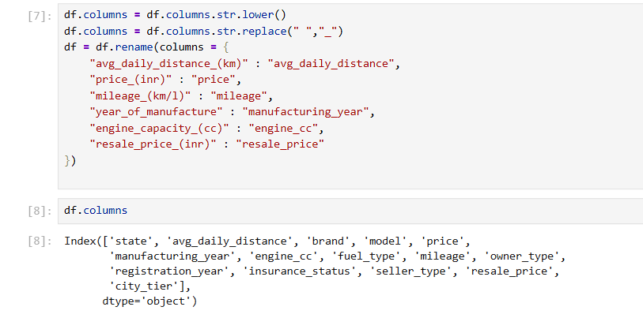

- Outliers : Outlier detection performed on price and resale price to check if there are extreme values or not in the dataset.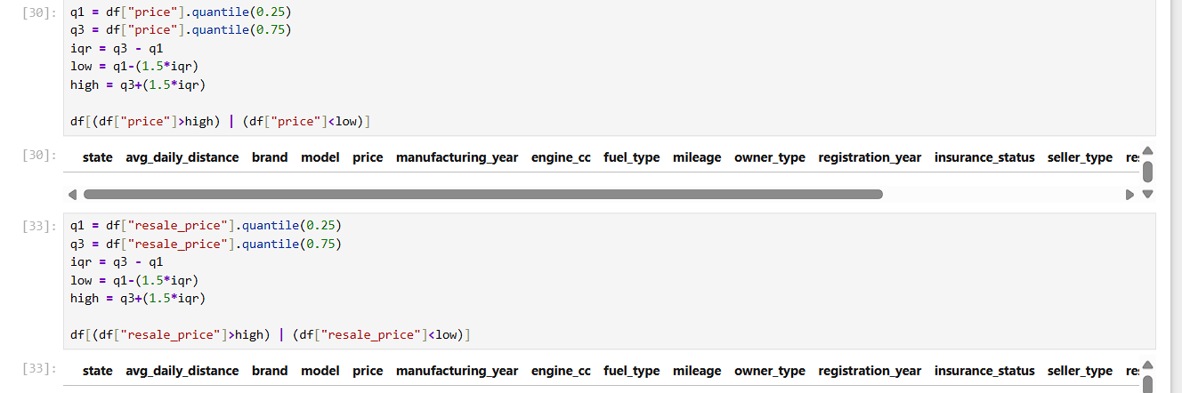

● Feature Engineering:
- Created depreciation by price – resale_price.
- Created depreciation_percentage from deprericiation.
- Created price_segment from price.

● Database Integration: Connected Python script to PostgreSQL and loaded the cleaned DataFrame into the database for SQL analysis.

- Data Analysis using SQL
We performed structured analysis in PostgreSQL to answer key business questions:
- Revenue by Brands: compared revenue of every brand exist in the data table.
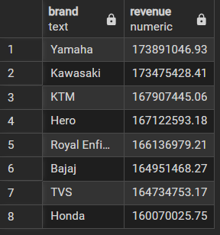
- Top 5 Brands by Average resale price : calculated average resale price of every brands and took top 5 best performing brands, order by highest to lowest
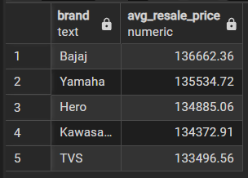
- Bikes with Petrol fuel and Expired Insurance: 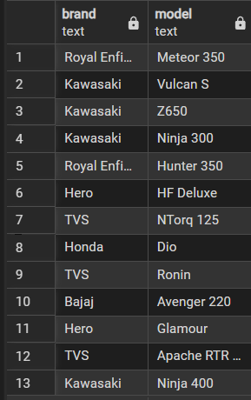

- The Number of Bikes of Every Owner type: calculated the the number of bikes hold by different owner types.
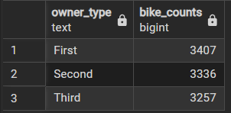

- Average Depreciation and its Percentage by Fuel type: 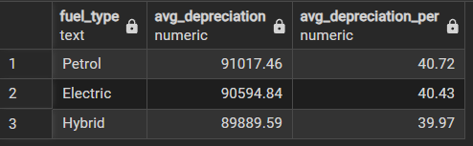

- Brand Ranking: ranked the brand using window function based on their average resale price. 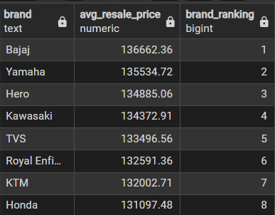

- Top 3 bikes per Brand: with using common table expression and window function, I found the top 3 bike models in every brand by resale price.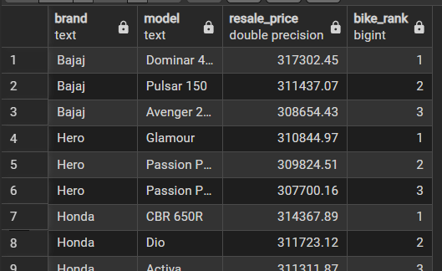

- Contribution of States : here we calculated the percentage of every state contribution in the total resale price.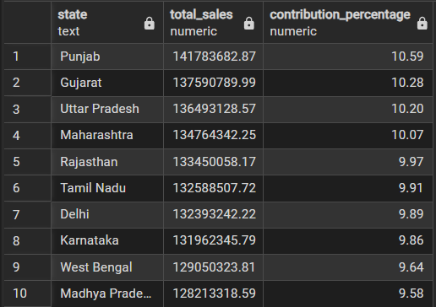

- Dashboard in Power BI
Finally, we built an interactive dashboard in Power BI to present insights visually.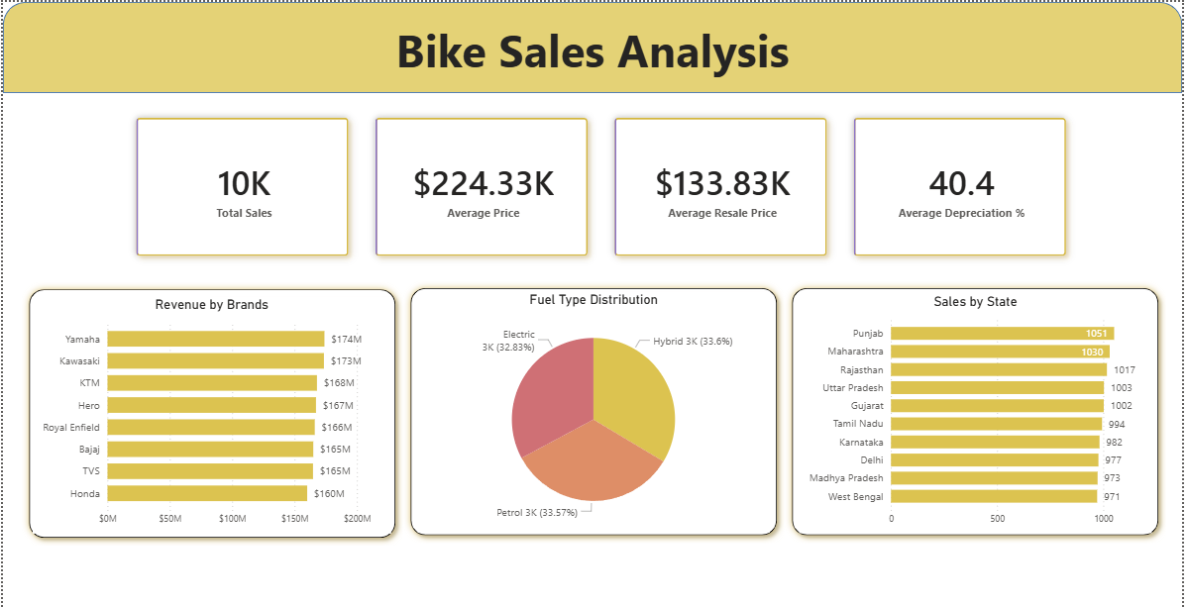

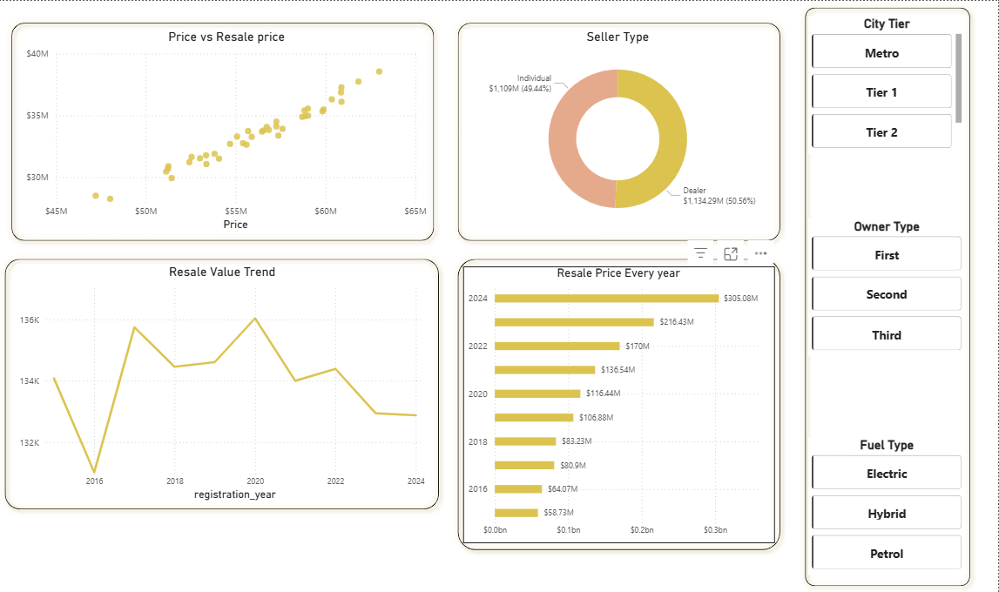

- Business recommendation:
- Dealers should prioritize stocking brands with lower depreciation percentages, as these brands retain higher resale value and reduce inventory risk in the used-bike market.
- Bikes with expired insurance show lower resale value. Offering insurance renewal packages at the time of resale can improve buyer confidence, increase resale prices, and accelerate sales.
- Fuel types with lower average depreciation represent safer resale investments. Dealers and platforms should actively promote these fuel categories to maximize long-term value retention.
- Brands that demonstrate strong and consistent sales performance across multiple states should be prioritized for expansion, as they indicate stable demand and wider market acceptance.

